**Mid Exam**

**Semester 20243**

Subject : **Distributed and Parallel System**

Study Program : Informatics

Student Name : Fetrik Cola.P.V.Sitepu

Student ID :001202300173

Instructions for Students

1. This examination consists of 2 problems.
2. All answers to be written in answer space provided with numbers are written accordingly.
3. Students are to use proper English and are required to write neatly and clearly.
4. Any attempts on cheating and plagiarism will result in an immediate zero score.

You are being tasked to form a group of 1 - 2 students and create a project to handle both **Backend** and **Frontend** of a web application. In order to make sure everyone has the same standardized environment and softwares, you decided to implement a container-based approach using Docker.

1. Create a frontend application using any framework / platform of your choice
2. Create a backend application using any framework / platform of your choice
3. Both point number 1 and 2 must have a Dockerfile
4. Create a docker-compose.yml file to handle deployment process

To document this better, create a report that shows what kind of application you are creating including the screenshots. **The important aspect is you need to explain and put the step-by-step process of deploying the application using Docker**. Put all source code on GitHub including the report, then submit the link

**Project structure**

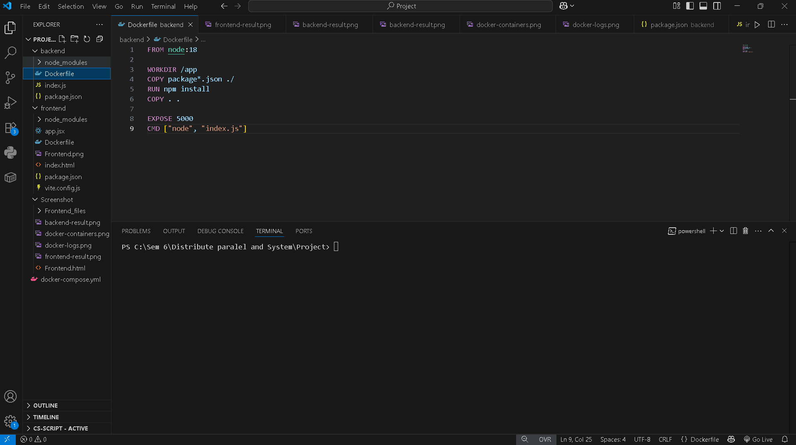

### 

### 

### 

### 

### **1. Screenshot Frontend Result**

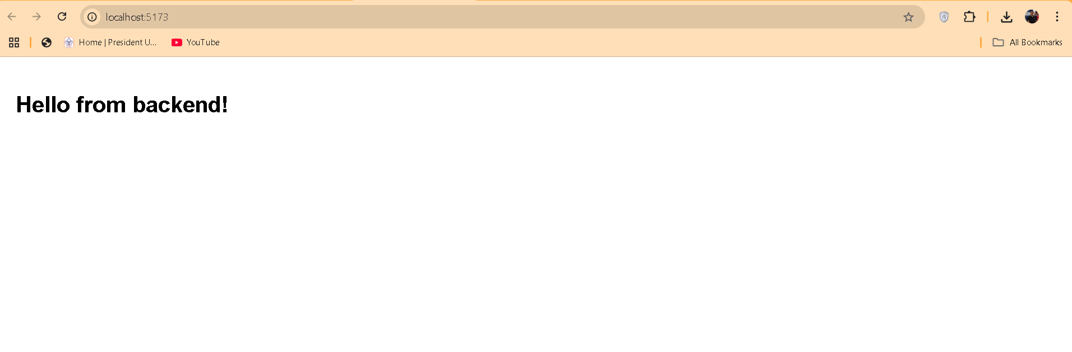

* Screenshot from browser <http://localhost:5173>
* Make sure you see the message "Hello from backend!"
* Include the URL bar showing localhost:5173

### **2. Screenshot Backend API Result**

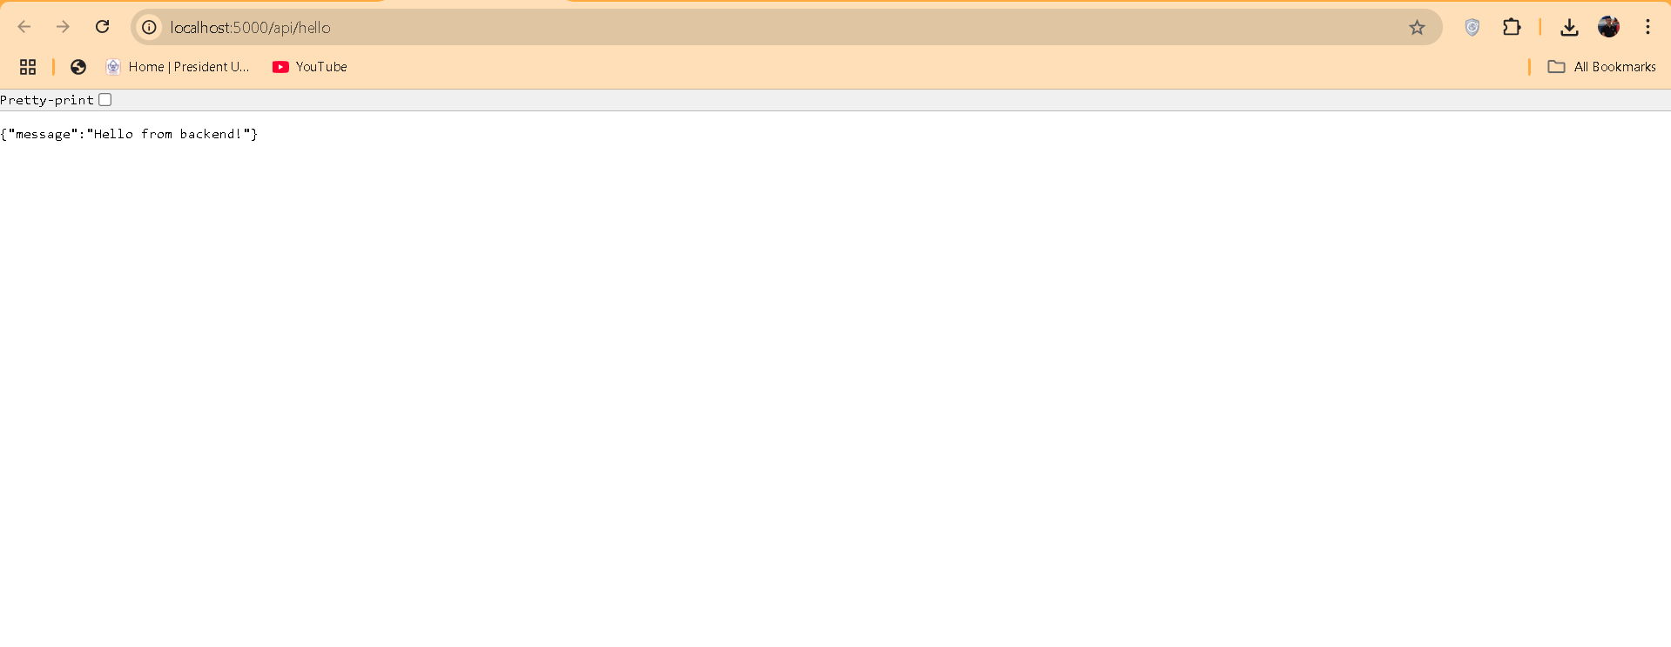

* Screen capture from browser <http://localhost:5000/api/hello>
* Make sure to see JSON response
* Include URL bar showing localhost:5000/api/hello

### **3. Screenshot Docker Containers**

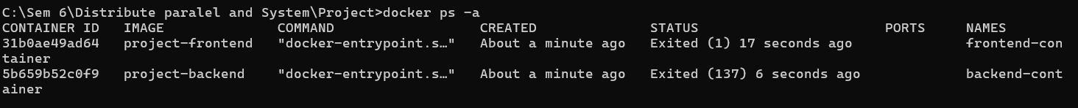

* Capture a terminal screen showing both containers running
* Make sure you see the backend-container and frontend-container

### **4. Screenshot Docker Logs**

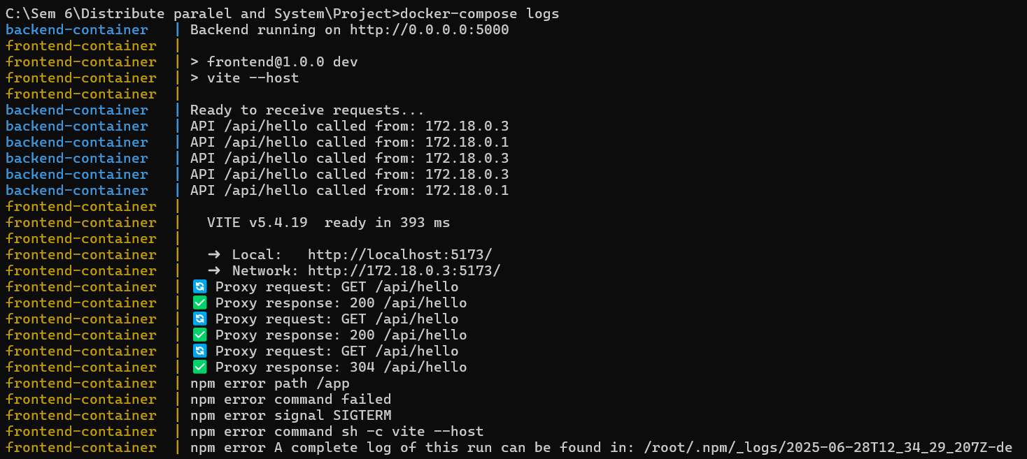

* Run: docker-compose logs
* Capture a screen showing success logs from both services
* Make sure it shows "Backend running" and "Network: http://0.0.0.0:5173"

**Docker Result**

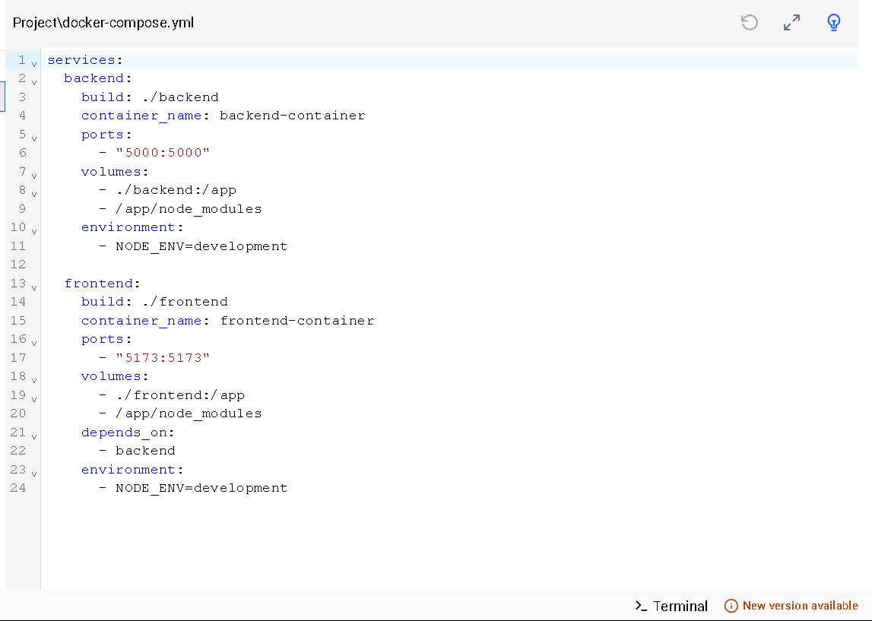

**Github Link:**

<https://github.com/fetrikcola/docker-web-app/tree/main/backend>